**OUTPUT**

**Command Prompt (using ‘curl’):**

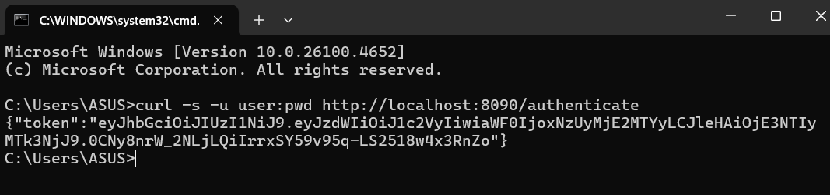

**IntelliJ IDEA:**

